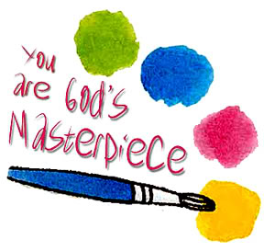 Sportsmen’s Ministry
Women’s Group
Paint & Devotional

We will be hosting a Paint/Crafty Project & Devotion for women on a monthly basis. The classes will be held on the last Tuesday of each month from 6:00 pm – 8:30 pm at the old Marine Fishery Bldg. located at 1367 Hwy. 17 South, Eliz. City, NC 27909. The first class will be held on May 30, 2017.
We can only accommodate 20 people at the time, so be sure to register soon. The classes will be $20 a person* (some may be $25 depending on the project), however, this fee includes all supplies and a portion will be donated back to the Sportsmen’s Ministry.
*We will need for you to pre-register and pay for the class in advance so that we can have the supplies ready for you to have FUN!
To register for the class or if you have any questions, please feel free to call/text or email:
Tammy Colson at 252-333-8806 or email: colson.tammy@gmail.com
Lynne Brothers at 252-339-5218 or email: lynnebrothers50@gmail.com
I will be posting a picture of the project for each month on FOL Sportsmen Ministry Facebook Page (send friend request if you haven’t already) and on the website: www.soulhunters.us (also a link on the Facebook Page)

